**CC 1** **NAME : VISWAS GA**

**ROLL NO : 727721eucs184**

**QUESTION 1** :

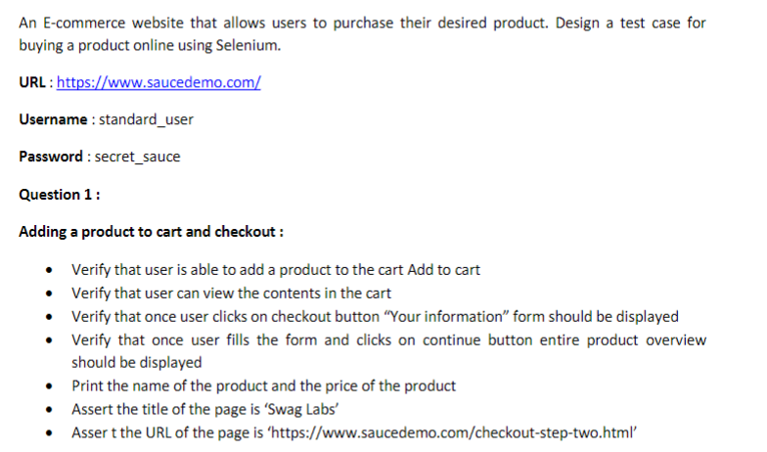

**CODE :**

package com.cc1;

import java.util.List;

import org.openqa.selenium.By;

import org.openqa.selenium.WebDriver;

import org.openqa.selenium.WebElement;

import org.openqa.selenium.chrome.ChromeDriver;

import org.openqa.selenium.chrome.ChromeOptions;

import io.github.bonigarcia.wdm.WebDriverManager;

public class cc1_qn1 {

public static void main(String[] args) {

// **TODO** Auto-generated method stub

ChromeOptions co = new ChromeOptions();

co.addArguments("--remote-allow-origins=*");

WebDriverManager.*chromedriver*().setup();

WebDriver driver = new ChromeDriver();

driver.get("https://www.saucedemo.com/");

driver.manage().window().maximize();

driver.findElement(By.*xpath*("/html/body/div/div/div[2]/div[1]/div/div/form/div[1]/input")).sendKeys("standard_user");

driver.findElement(By.*xpath*("/html/body/div/div/div[2]/div[1]/div/div/form/div[2]/input")).sendKeys("secret_sauce");

driver.findElement(By.*xpath*("/html/body/div/div/div[2]/div[1]/div/div/form/input")).click();

driver.findElement(By.*xpath*("/html/body/div/div/div/div[2]/div/div/div/div[1]/div[2]/div[2]/button")).click();

String remove = driver.findElement(By.*xpath*("/html/body/div/div/div/div[2]/div/div/div/div[1]/div[2]/div[2]/button")).getText();

if(remove.equals("Remove"))

{

System.***out***.println("User is able to add product to cart");

}

else

{

System.***out***.println("User is not able to add product to cart");

}

driver.findElement(By.*xpath*("/html/body/div/div/div/div[1]/div[1]/div[3]/a")).click();

boolean presents = driver.findElement(By.*xpath*("/html/body/div/div/div/div[2]/div/div[1]/div[3]")).isDisplayed();

System.***out***.print("Contents Displayed in cart : "+presents);

driver.findElement(By.*xpath*("/html/body/div/div/div/div[2]/div/div[2]/button[2]")).click();

if(driver.findElement(By.*xpath*("/html/body/div/div/div/div[1]/div[2]/span")).getText().equals("Checkout: Your Information"))

{

System.***out***.println("Your Information displayed");

}

else

{

System.***out***.println("Your Information not displayed");

}

driver.findElement(By.*xpath*("/html/body/div/div/div/div[2]/div/form/div[1]/div[1]/input")).sendKeys("Viswas");

driver.findElement(By.*xpath*("/html/body/div/div/div/div[2]/div/form/div[1]/div[2]/input")).sendKeys("GA");

driver.findElement(By.*xpath*("/html/body/div/div/div/div[2]/div/form/div[1]/div[3]/input")).sendKeys("123456");

driver.findElement(By.*xpath*("/html/body/div/div/div/div[2]/div/form/div[2]/input")).click();

String overview = driver.findElement(By.*xpath*("/html/body/div/div/div/div[1]/div[2]/span")).getText();

if(overview.equals("Checkout: Overview"))

{

System.***out***.println("Product overview is displayed");

}

else

{

System.***out***.println("Product overview is not displayed");

}

List<WebElement> items = driver.findElements(By.*xpath*("//div[@class=\"inventory_item_name\"]"));

List<WebElement> price = driver.findElements(By.*xpath*("//div[@class=\"inventory_item_price\"]"));

for(int i=0;i<items.size();i++)

{

System.***out***.println(items.get(i).getText()+" - "+price.get(i).getText());

}

String actualTitle = driver.getTitle();

String expectedTitle = "Swag Labs";

if(actualTitle.equals(expectedTitle))

{

System.***out***.println("Title matches");

}

else

{

System.***out***.println("Title Not matches");

}

String actualURL = driver.getCurrentUrl();

String expectedURL = "https://www.saucedemo.com/checkout-step-two.html";

if(actualURL.equals(expectedURL))

{

System.***out***.println("URL matches");

}

else

{

System.***out***.println("URL Not matches");

}

}

}

**OUTPUT :**

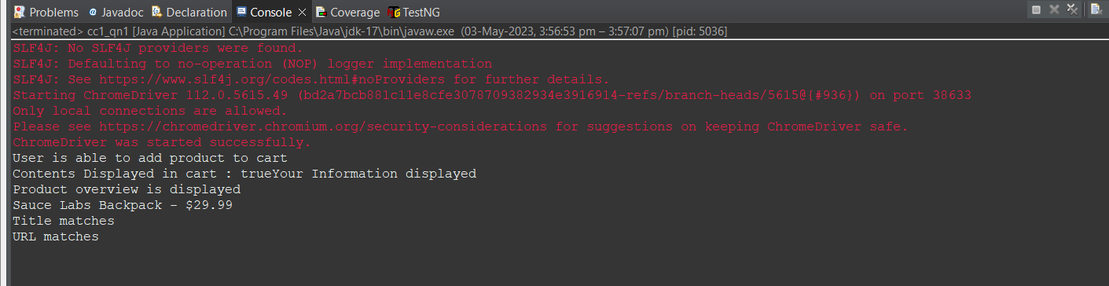

**QUESTION 2 :**

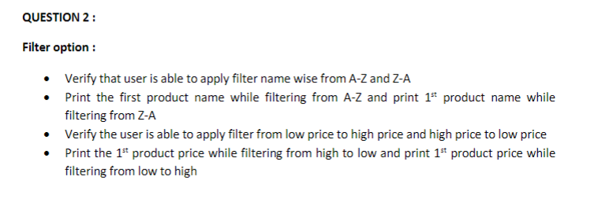

**CODE :**

package com.cc1;

import org.openqa.selenium.By;

import org.openqa.selenium.WebDriver;

import org.openqa.selenium.WebElement;

import org.openqa.selenium.chrome.ChromeDriver;

import org.openqa.selenium.chrome.ChromeOptions;

import io.github.bonigarcia.wdm.WebDriverManager;

public class cc1_qn2 {

public static void main(String[] args) throws InterruptedException {

// **TODO** Auto-generated method stub

WebDriverManager.*chromedriver*().setup();

ChromeOptions co=new ChromeOptions();

co.addArguments("--remote-allow-origins=*");

WebDriver driver=new ChromeDriver(co);

driver.get("https://www.saucedemo.com/");

Thread.*sleep*(2000);

driver.manage().window().maximize();

WebElement name=driver.findElement(By.*xpath*("//*[@id=\"user-name\"]"));

name.sendKeys("standard_user");

Thread.*sleep*(2000);

WebElement pwd=driver.findElement(By.*xpath*("//*[@id=\"password\"]"));

pwd.sendKeys("secret_sauce");

Thread.*sleep*(2000);

WebElement btn=driver.findElement(By.*xpath*("//*[@id=\"login-button\"]"));

btn.click();

Thread.*sleep*(2000);

WebElement c1=driver.findElement(By.*xpath*("//*[@id=\"header_container\"]/div[2]/div/span/select"));

c1.click();

Thread.*sleep*(2000);

WebElement c2=driver.findElement(By.*xpath*("//*[@id=\"header_container\"]/div[2]/div/span/select/option[1]"));

c2.click();

Thread.*sleep*(2000);

String e1=driver.findElement(By.*xpath*("//*[@id=\"item_4_title_link\"]/div")).getText();

System.***out***.println("A to Z Order's 1st Product Title: "+e1);

WebElement c3=driver.findElement(By.*xpath*("//*[@id=\"header_container\"]/div[2]/div/span/select/option[2]"));

c3.click();

Thread.*sleep*(2000);

String e2=driver.findElement(By.*xpath*("//*[@id=\"item_3_title_link\"]/div")).getText();

System.***out***.println("Z to A Order's 1st Product Title: "+e2);

Thread.*sleep*(1000);

WebElement c4=driver.findElement(By.*xpath*("//*[@id=\"header_container\"]/div[2]/div/span/select/option[3]"));

c4.click();

Thread.*sleep*(2000);

String e3=driver.findElement(By.*xpath*("//*[@id=\"item_2_title_link\"]/div")).getText();

System.***out***.println("Low to High Order's 1st Product Title: "+e3);

WebElement c5=driver.findElement(By.*xpath*("//*[@id=\"header_container\"]/div[2]/div/span/select/option[4]"));

c5.click();

Thread.*sleep*(2000);

String e4=driver.findElement(By.*xpath*("//*[@id=\"item_5_title_link\"]/div")).getText();

System.***out***.println("High to Low Order's 1st Product Title: "+e4);

Thread.*sleep*(1000);

}

}**OUTPUT :**

